Colonel Vasile IONESCU
Head of International Defence Cooperation Directorate

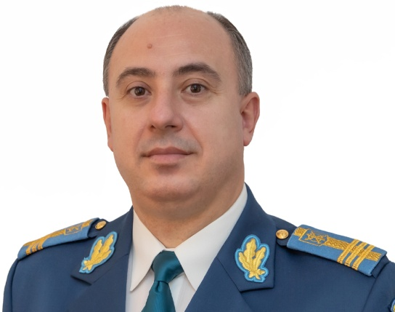
Colonel Vasile IONESCU was born on 12th of October 1974, in Ploieşti, Prahova County. He graduated from “Dimitrie Cantemir” Military High School Breaza in 1993 and “General Bungescu” Anti-Aircraft Artillery and Missile Institute Braşov in 1997. He started his military career as an anti-aircraft artillery platoon commander and, subsequently, he had various assignments within Air Defence units belonging to the Romanian Air Force Staff. Between 2010 and 2020, he assumed the position of the chief of the international relations structures within the Romanian Air Force Staff and Romanian Defence Staff. Starting with 15th of December 2020, he assumed the position of Director of the Romanian Air Force Staff, and from 15th of October 2021, he was assigned Head of International Defence Cooperation Directorate.
Colonel Vasile IONESCU is married and he has a daughter.
EDUCATION:
1993 – “Dimitrie Cantemir” Military High School, Breaza;
1997 – “General Bungescu” Anti-Aircraft Artillery and Missile Institute, Braşov;
2002 – Anti-Aircraft Artillery battery commanders course, Bucharest;
2003 – Communication Sciences and Public Relations MA, National University of Political Studies and Public Administration, Bucharest;
2008 – Integrated Command and Control system course, Allied Air Command, Izmir, Turkey;
2009 – Brigade Staff Officer course, “Carol I” National Defence University, Bucharest;
2009 – NATO exercises planning course, Allied Joint Force Command Headquarters – Mobile Training Team, Buzău;
2011 – Inter-Arms Command – Air Force MA, “Carol I” National Defence University, Bucharest;
2013 – Seminar on project management organized by ROMATSA R.A., Bucharest;
2016 – Postgraduate course for Military Sciences, Information and Public order, Regional Department of Defence Resources Management Studies, Brașov;
2017 – Principles and guidelines for UN peacekeeping operations course, on-line, Peace Operations Training Institute;
2018 – Air Defence and Missile Defence course, Competence Centre for Surface Based Air and Missile Defence, Ramstein, Germany;
2020 – Postgraduate course for national security, National Defence College, Bucharest;
2020 – Course on the common foreign and security policy of the European Union, European Security and Defence College, Bruxelles, Belgia;
2021 – Public affairs course for commanders, Ministry of National Defence, Bucharest.
PROFESSIONAL EXPERIENCE:
1997-2002 – Anti-Aircraft Artillery platoon commander, 45th Anti-Aircraft Artillery Battalion;
2002-2005 – Chief of Command Post crew, 6th Surface-to-Air Missiles Battalion;
2005-2008 – Staff officer, Live Exercises Office, Main Air Operational Command;
2008-2010 – Staff officer, Exercises Office, Romanian Air Force Staff;
2010-2020 – Chief of International Relations Office/Section, Romanian Air Force Staff;
2019-2020 – Chief of International Relations Branch, Romanian Defence Staff;
2020-2021 – Director, Romanian Air Force Staff;
Starting with 15th of October 2021 – Head, International Defence Cooperation Directorate.
PROMOTIONS:
1997 – 2nd Lieutenant;
2000 – Lieutenant;
2005 – Captain;
2010 – Major;
2015 – Lieutenant Colonel;
2018 – Colonel.
AWARDS AND MEDALS:
– Honorary Sign “In Homeland Service” for 15 years of military service;
– Honorary Sign “In Homeland Service” for 20 years of military service;
– Honorary Sign “In Homeland Service” for 25 years of military service;
– Emblem of Merit “In the Service of Romania's Military” 3rd class;
– Emblem of Merit “In the Service of Romania's Military” 2nd class;
– Emblem of Honor of the Romanian Air Force Staff;
– Emblem of Honor of the Romanian Land Forces Staff;
– Emblem of Honor of the Romanian Navy Forces Staff;
– Emblem of Honor of the Romanian Defence Staff;
– National Order “Military Virtue” in Knight Rank.
LANGUAGES:
– English and French.

